Project Report: II
Parking Lot Management
Problem statement:
To build a “Parking Lot Management” system on a web-application that tracks entry and exit of vehicles in a parking lot, track available parking spaces, and calculate parking fees.
Aim:
To build a user-friendly, easily understandable, yet detailed parking lot management web-application using recently learnt modules of Figma (Prototype), Angular (Frontend), C# (API) and SQL (Backend).
The parking lot has a fixed number of slots (e.g., 50).
Users:
- Parking Attendant – records vehicle entry and exit.
- Supervisor – monitors parking usage and daily reports.
Introduction:
Following the first report submitted earlier, the given has project has been finetuned and added few extra features after discussion. The project additional features and finetuning includes:
- Added Admin feature.
- Added Slot Management page.
- Added image capturing system.
- Added logout and back buttons for easier navigation.
- Bigger UI for more readability.
- Added colorful SCSS apart from primary choice for colors.
- Every page was added with responsive layout.
- Fixed an issue on Chart filters.
- Fixed an issue where roles were not part of login authentication.

- Admin Page:

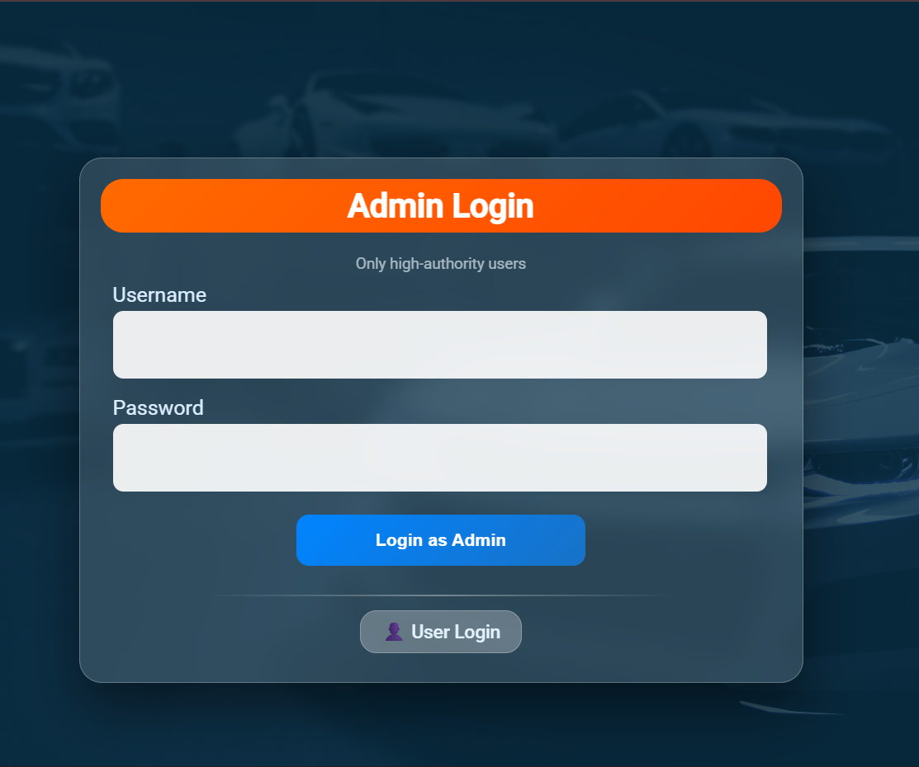
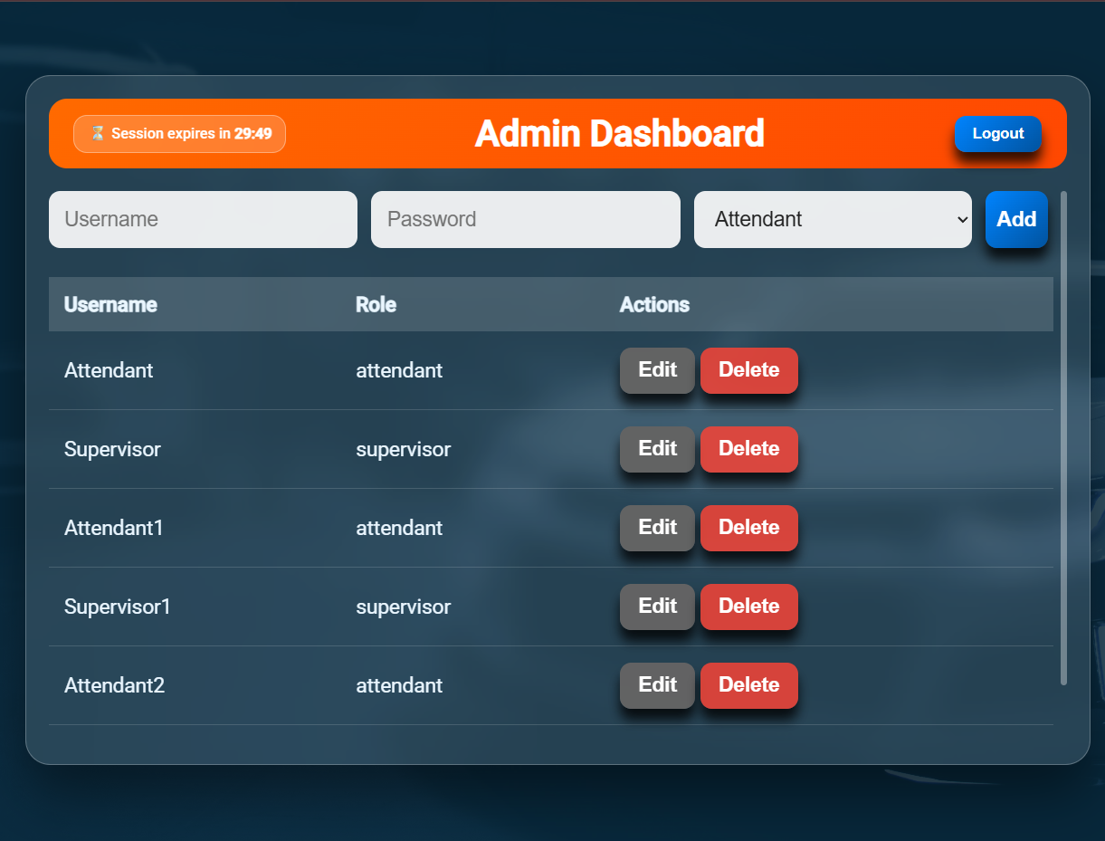
Admin user has been added with a fixed username and password which cannot be further edited.
Admins can now add, edit or delete users for either of the roles only (Attendant, Supervisor).
The updated password or username will be directly in use and the attendant or supervisor themselves cannot edit their username or password.

- Slot Management:
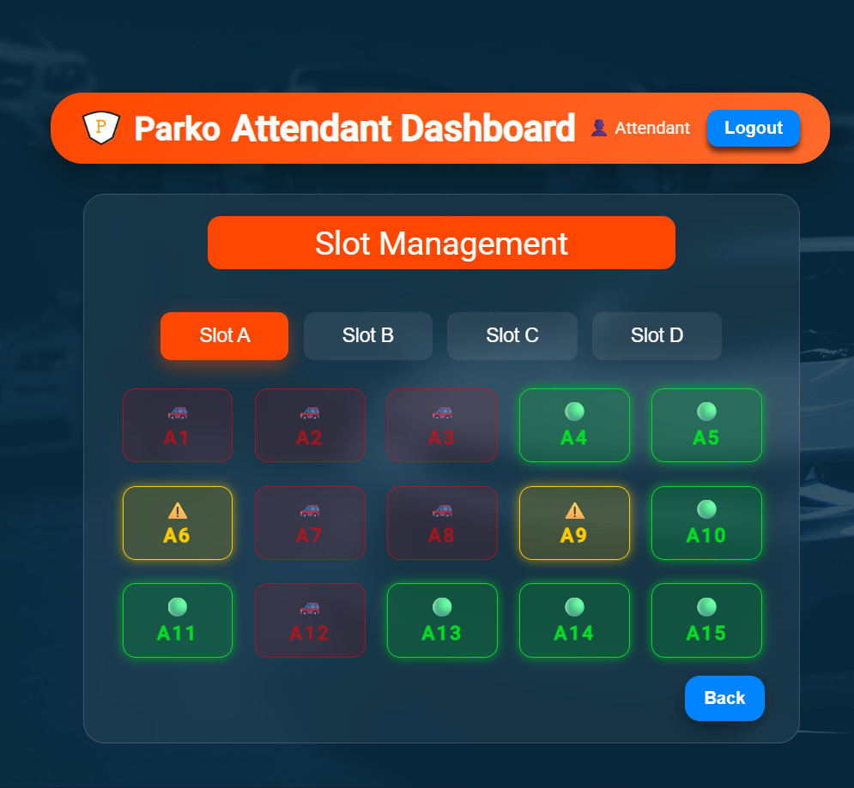
Attendants can now manage slots and look which slots are being occupied or free.
Attendants can select of any of the free slots to mark them with () to reserve slots for emergency or block slots incase of maintenance. The blocking can be toggled just by simply clicking the respective slot.
Note: The slots that are already being occupied by previous vehicles cannot be blocked.

- Image Capturing system:
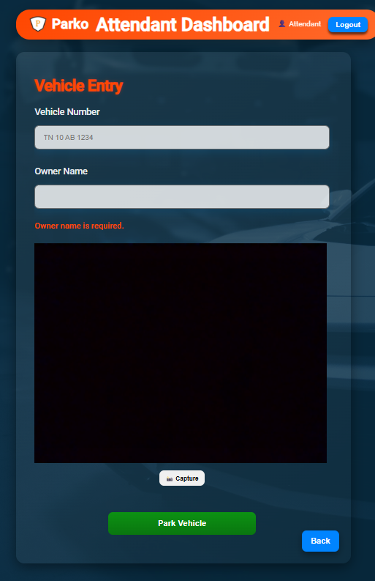
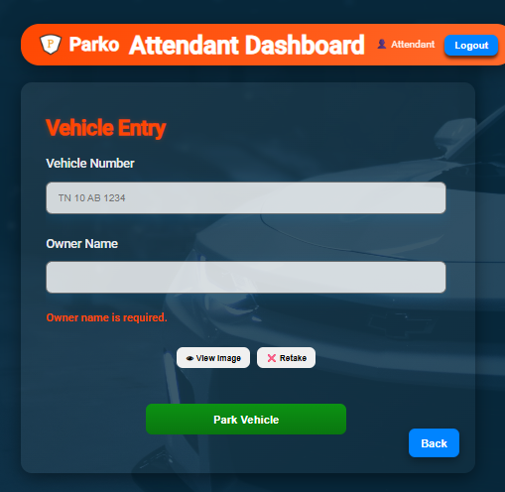
Added image capturing system in attendant vehicle entry page to capture the image of the vehicle using a available cam and store it.
This image- capturing system was added to improve security of the vehicles parked and for a record of both the driver’s identity and the vehicle image in any case.
The captured image can only be viewed again by supervisor once the vehicle has been booked a slot and parked.
However, the attendant has options to view image and retake the image as many times before entry to ensure a proper and a clear image.
- Logout and back buttons:
Logout and back buttons are added for easier navigation across page for the users.
The ‘Logout’ button instantly logs the user out and navigates the user back to login page. While the ‘Back’ button navigates to just one page back allowing safer navigation.
Once the user logs out or closes the tab, the token for role is immediately set to null and the user have to re-login to access the page. This methodology enables more secure application. In any case the user cannot access the page of other user or navigate to them just by entering the link preventing risks.
- Bigger UI:
Earlier the whole layout of the page was designed smaller with smaller fonts and now it has been adjusted to bigger layout for more readability that almost covers full page.
Fixed a ‘top-bar’ that contains app logo, app name, page name, username of the user and a logout button fixed atop.
- Colorful UI:
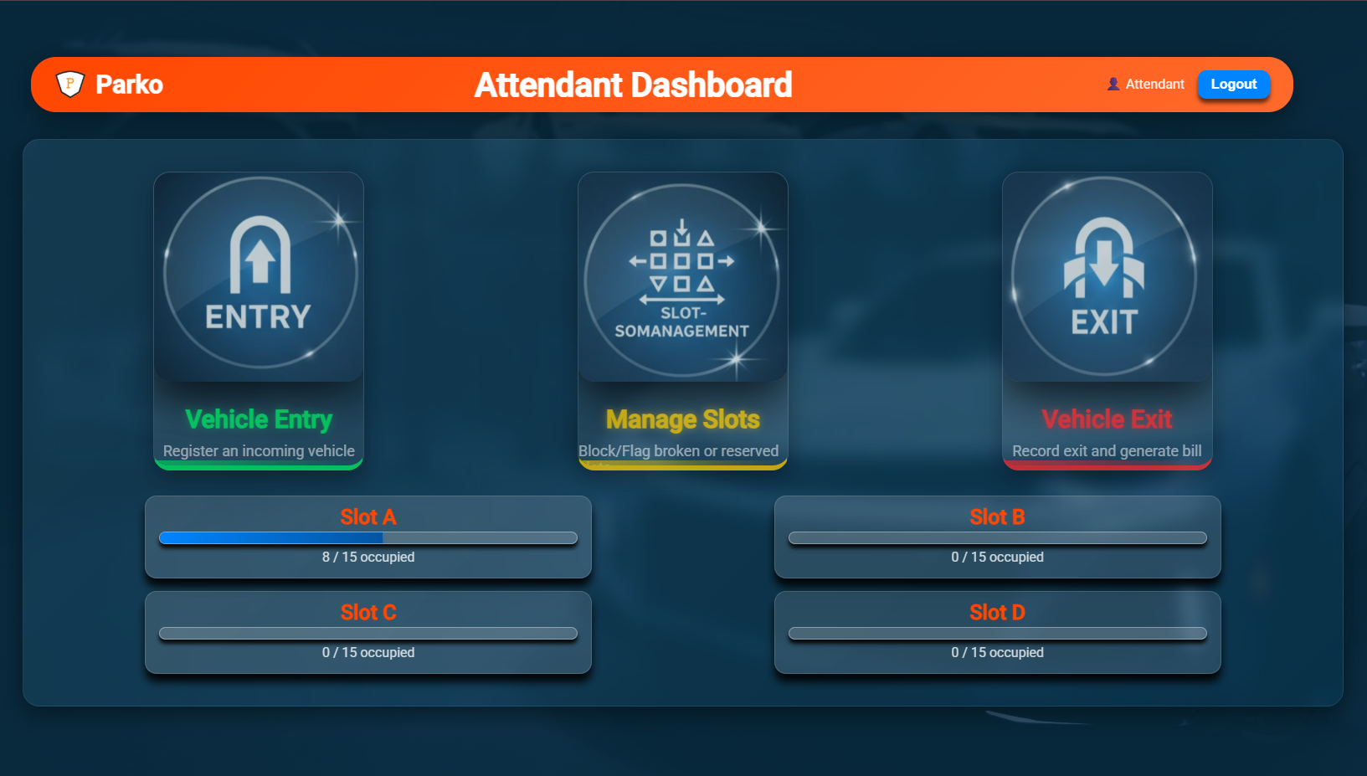
The attendant dashboard now comes with updated card icons and more colors apart from the primary choice of colors.
The three cards contain three different colors red, blue and green symbolizing the traffic signal and also the entry, manage and exit pages.
The attendant dashboard also comes with a enhanced UI/UX that allows visibility of count of vehicles parked in each slot.
- Responsive layout:
Every page was added with a responsive SCSS layout that allows working between windowed and full screen without entirely collapsing the layout of the page.
Loading screens and error messages have been prevented from collapsing the whole layout. Added scroll bars in-case of page overflow.
- Rectifying chart issues:
Charts were added as a part of supervisor page that visualizes amount of income based of filters applied such as date, week, month and year.
An issue was found last time where the date filter only showcased a single point on chart without forming a graph. The issue was later addressed by adding time stamp on the chart for date filter that visualizes the income obtained in 24-hours.
- Login authentication:
Login is the first and most important part of user authentication in any application.
An issue was found last time where a user can switch between roles or skip login completely by tweaking the URL. When any user or complete stranger knows the URL of a certain page the person can easily enter the page without navigating through the login first.
This issue was addressed by adding token rule and auth and role guards for the application. So, whenever any person tries to enter a URL of the application the person will be directly navigated to login page.
This method brings more security and prevents data loss or misuse by any unauthenticated persons.
Future Improvements:
Future improvements and additional features have been identified that can be added later on the project in upcoming days. Few improvements and features spotted are:
- IOT aided parking that automatically updates the slot data.
- Number plate reading system for automatic entry and capture of vehicles on entry and generation of fee on exit.
- RFID enabled parking where drivers can hold a card and scan it on entry and exit.
- Personal slot booking through public application for parking on special occasions.

